**Case Studies & Guesstimates for FinTech Industries**

The FinTech industry has emerged as a transformative force, blending technology with financial services to boost efficiency, accessibility, and customer experience. In today's digital age, FinTech is vital for democratizing financial services and granting underserved populations access to banking, credit, and investment opportunities.

It fosters innovation through digital payment systems, peer-to-peer lending platforms, and blockchain technology, significantly altering traditional banking practices.

Data scientists play a pivotal role in the FinTech boom, leveraging advanced analytics and machine learning to enhance risk assessment, fraud detection, and personalized financial services. Their expertise allows FinTech companies to analyze vast amounts of financial data, uncovering critical insights that drive strategic decision-making, optimize operations, and improve customer satisfaction. By harnessing the power of data, data scientists enable FinTech firms to remain competitive, continuously innovate, and contribute to a more inclusive and efficient financial ecosystem, ultimately transforming the way financial services are delivered and experienced.

Furthermore, data scientists enable FinTech companies to analyze vast amounts of financial data to uncover insights that drive strategic decision-making and operational optimization. For instance, they can identify trends and patterns that inform product development, marketing strategies, and customer retention initiatives. This data-driven approach ensures that FinTech firms remain competitive in a rapidly evolving market, continually innovating to meet changing consumer demands.

In summary, the FinTech industry is at the forefront of transforming financial services through technology. Data scientists play a crucial role in this transformation, providing the analytical expertise necessary to harness the power of data. Their contributions help FinTech firms enhance risk management, personalize services, and make informed strategic decisions, ultimately leading to a more inclusive, efficient, and customer-centric financial ecosystem.

**PART - I**

**Product Dissection**

**1. Platform Selection**

**Question:** Choose a leading platform from a domain related to the **FinTech** industry. Justify your selection by discussing the platform's popularity, impact, and relevance in its industry.

**Answer 1:** 

## **PhonePe: A Leading Platform in the Indian Fintech Industry**

PhonePe is an Indian digital payment and financial services companyheadquartered in Bengaluru, Karnataka, India. PhonePe was founded in December 2015, by Sameer Nigam, Rahul Chari and Burzin Engineer. The PhonePe app, based on the Unified Payment System(UPI), went live in August 2016.

The PhonePe app is accessible in 11 Indian languages.It enables users to perform various financial transactions such as sending and receiving money, recharging mobile and DTH, making utility payments, conducting in-store payments.

**PhonePe** emerges as a dominant player in the Indian fintech landscape due to its widespread adoption, innovative features, and significant impact on the digital payments ecosystem.

**Popularity:** As one of the pioneers of UPI-based payments, PhonePe has garnered a massive user base, becoming synonymous with digital transactions in India. Its extensive reach across both urban and rural areas underscores its popularity and accessibility. PhonePe has solidified its position as a dominant player in India's digital payments landscape. With a substantial market share of approximately 49% in UPI transactions as of April 2024, it has consistently outpaced its competitors. This leadership is attributed to its early adoption of UPI, extensive user base, and a robust network of merchants.

**Impact:** PhonePe has revolutionised the way Indians make payments, contributing significantly to the government's push for a cashless economy. By simplifying financial transactions and promoting financial inclusion, it has empowered millions of users.

**Relevance:** PhonePe's deep integration with the Indian financial landscape, coupled with its continuous innovation in services like insurance, investments, and credit, solidifies its position as a leading fintech platform. Its alignment with the government's digital India initiative further enhances its relevance in the industry.

In conclusion, PhonePe's combination of widespread adoption, transformative impact, and strategic alignment with the Indian market makes it a compelling choice as a leading fintech platform.

**2. Core Features and Functionalities**

**Question:** Research and list the core features and functionalities of the selected platform. Describe how these features contribute to the platform’s success and user engagement.

Answer 2. PhonePe's success can be attributed to its core features and functionalities that cater to a wide range of user needs and preferences.

* **Peer-to-Peer (P2P) Payments:** The platform's foundation lies in seamless and instant money transfers between users, eliminating the need for physical cash. This core feature has driven mass adoption and established PhonePe as a household name.
* **UPI-based Payments:** Leveraging the Unified Payments Interface, PhonePe offers a secure and convenient way to make payments at various merchants, both online and offline. This integration has expanded the platform's utility and user base.
* **Recharge and Bill Payments:** Users can conveniently recharge mobile phones, DTH connections, and pay utility bills through the app, saving time and effort. This feature enhances user stickiness and increases transaction frequency.
* **Financial Services:** PhonePe has diversified its offerings to include investments, insurance, and loans. These additional services provide users with a comprehensive financial ecosystem, increasing customer engagement and loyalty.
* **QR Code-based Payments:** The integration of QR code payments has expanded the platform's reach to small merchants and facilitated offline transactions, driving merchant adoption and user convenience.
* **User Interface:** PhonePe's intuitive and user-friendly interface, coupled with multilingual support, has contributed significantly to its mass appeal and ease of use.
* **Security and Trust:** Robust security measures and trust-building initiatives have been instrumental in gaining user confidence and ensuring the platform's reliability.

By offering a comprehensive suite of financial services, coupled with a user-centric design and robust security, PhonePe has solidified its position as a leading digital payments platform in India, driving user engagement and loyalty.

### **3. Real World Problems**

**Question:** Identify the real-world problems that the platform aims to solve. Discuss how the platform addresses these problems through its features and functionalities.

**Real World Problems Addressed by PhonePe**

**1.** **Financial Inclusion**

* **Problem:** Many individuals in India are unbanked or underbanked, limiting their participation in the formal economy.
* **Solution:** PhonePe provides a platform for digital payments and financial services, empowering millions of unbanked and underbanked individuals to access the formal economy.

**2. Time Efficiency**

* **Problem:** Traditional transaction processes can be time-consuming and inconvenient.
* **Solution:** PhonePe streamlines various transaction processes, saving users valuable time by offering convenient and efficient solutions for recharging mobile phones, paying bills, and transferring money.

**3. Cashless Transactions**

* **Problem:** Reliance on physical cash leads to operational inefficiencies and lack of transparency.
* **Solution:** PhonePe promotes a cashless economy by providing a secure and efficient digital payment option, reducing reliance on physical cash and increasing transparency.

**4. Merchant Empowerment**

* **Problem:** Small merchants often lack access to digital payment options, limiting their customer base and sales.
* **Solution:** PhonePe’s QR code-based payment system empowers small merchants by providing them with a digital payment option, expanding their customer base and increasing sales.

**5. Financial Access**

* **Problem:** Limited access to financial services, especially in rural areas.
* **Solution:** PhonePe’s foray into financial services, including investments and insurance, improves access to these products for a wider population, particularly in rural areas.

**How PhonePe Addresses These Problems**

* **Digital Payments and Financial Services:** Enhances financial inclusion by enabling unbanked and underbanked individuals to participate in the formal economy.
* **Streamlined Transaction Processes:** Saves time for users by simplifying the processes for mobile recharges, bill payments, and money transfers.
* **Secure and Efficient Digital Payments:** Promotes a cashless economy, reducing the reliance on physical cash and increasing transaction transparency.
* **QR Code-Based Payment System:** Empowers small merchants by providing a digital payment option, which helps expand their customer base and increase sales.
* **Access to Financial Products:** Improves financial access through services like investments and insurance, particularly benefiting rural populations.

By addressing these challenges, PhonePe has transformed the way people transact and has significantly contributed to the overall economic growth and development of India.

**Database Management & Schema Design**

### **4. Schema Design**

**Question:** Based on the features and functionalities you have identified, design a schema that reflects the platform’s data structure. Define the key entities, attributes, and relationships that underpin these features.

**Answers: Schema Design for Phonepe**

The schema design for Phonepe should reflect its core features and functionalities, ensuring efficient data management and enabling the platform to deliver a seamless user experience. Below is an overview of the key entities, attributes, and relationships.

#### **Key Entities and Attributes**

1. **Users Table**

| Attribute | Type | Description |
| --- | --- | --- |
| UserID | INT PRIMARY KEY | Unique identifier for each user. |
| Name | VARCHAR(255) | Full name of the user. |
| Email | VARCHAR(255) UNIQUE NOT NULL | Unique email address of the user. |
| PhoneNumber | VARCHAR(15) UNIQUE NOT NULL | Unique phone number of the user. |
| Address | TEXT | Physical address of the user. |
| DateOfBirth | DATE | Date of birth of the user. |
| PasswordHash | VARCHAR(255) NOT NULL | Hashed password for user authentication. |
| Preferences | JSON | User preferences stored in JSON format. |

1. **Accounts Table**

| Attribute | Type | Description |
| --- | --- | --- |
| AccountID | SERIAL PRIMARY KEY | Unique identifier for each account. |
| UserID | INT | Foreign key referencing Users(UserID). |
| BankName | VARCHAR(255) | Name of the bank where the account is held. |
| AccountNumber | VARCHAR(20) | Bank account number. |
| IFSCCode | VARCHAR(11) | IFSC code of the bank branch. |
| Balance | DECIMAL(15, 2) | Current balance of the account. |

1. **Wallet Table**

| Attribute | Type | Description |
| --- | --- | --- |
| WalletID | SERIAL PRIMARY KEY | Unique identifier for each wallet. |
| UserID | INT | Foreign key referencing Users(UserID). |
| Balance | DECIMAL(15, 2) | Current balance of the wallet. |

1. **Transactions Table**

| Attribute | Type | Description |
| --- | --- | --- |
| TransactionID | SERIAL PRIMARY KEY | Unique identifier for each transaction. |
| UserID | INT | Foreign key referencing Users(UserID). |
| Amount | DECIMAL(15, 2) | The amount involved in the transaction. |
| Date | TIMESTAMP DEFAULT CURRENT_TIMESTAMP | Date and time of the transaction. |
| Type | transaction_type | Type of transaction: 'credit' or 'debit'. |
| Status | transaction_status | Status of the transaction: 'pending', 'completed', or 'failed'. |

1. **Payments Table**

| Attribute | Type | Description |
| --- | --- | --- |
| PaymentID | SERIAL PRIMARY KEY | Unique identifier for each payment. |
| PayerID | INT | Foreign key referencing Users(UserID) for the payer. |
| PayeeID | INT | Foreign key referencing Users(UserID) for the payee. |
| Amount | DECIMAL(15, 2) | Amount involved in the payment. |
| Date | TIMESTAMP DEFAULT CURRENT_TIMESTAMP | Date and time of the payment. |
| PaymentMethod | payment_method | Payment method used: 'UPI', 'Card', 'NetBanking', or 'Wallet'. |
| Status | transaction_status | Status of the payment: 'pending', 'completed', or 'failed'. |

1. **Merchants Table**

| Attribute | Type | Description |
| --- | --- | --- |
| MerchantID | SERIAL PRIMARY KEY | Unique identifier for each merchant. |
| MerchantName | VARCHAR(255) NOT NULL | Name of the merchant. |
| Address | TEXT | Address of the merchant. |
| ContactNumber | VARCHAR(15) | Contact number of the merchant. |
| AccountNumber | VARCHAR(20) | Account number of the merchant. |
| Status | VARCHAR(50) | Status of the merchant account. |
| UserID | INT | Foreign key referencing Users(UserID). |

1. **Bill Payments Table**

| Attribute | Type | Description |
| --- | --- | --- |
| BillID | SERIAL PRIMARY KEY | Unique identifier for each bill payment. |
| UserID | INT | Foreign key referencing Users(UserID). |
| BillerName | VARCHAR(100) NOT NULL | Name of the biller. |
| BillAmount | DECIMAL(15, 2) NOT NULL | Amount of the bill. |
| DueDate | DATE NOT NULL | Due date of the bill. |
| PaymentDate | TIMESTAMP | Date and time when the bill was paid. |
| Status | VARCHAR(20) NOT NULL | Status of the bill payment: 'paid' or 'unpaid'. |
| CreatedAt | TIMESTAMP DEFAULT CURRENT_TIMESTAMP | Date and time when the bill payment record was created. |
| UpdatedAt | TIMESTAMP DEFAULT CURRENT_TIMESTAMP | Date and time when the bill payment record was last updated. |

1. **FraudDetection Table**

| Attribute | Type | Description |
| --- | --- | --- |
| FraudID | SERIAL PRIMARY KEY | Unique identifier for each fraud detection record. |
| UserID | INT | Foreign key referencing Users(UserID). |
| TransactionID | INT | Foreign key referencing Transactions(TransactionID). |
| Status | fraud_status | Status of the fraud investigation: 'under_review', 'cleared', or 'flagged'. |

1. **Notifications Table**

| Attribute | Type | Description |
| --- | --- | --- |
| NotificationID | SERIAL PRIMARY KEY | Unique identifier for each notification. |
| UserID | INT | Foreign key referencing Users(UserID). |
| Message | TEXT | Content of the notification message. |
| Date | TIMESTAMP DEFAULT CURRENT_TIMESTAMP | Date and time of the notification. |
| ReadStatus | BOOLEAN DEFAULT FALSE | Whether the notification has been read or not. |

1. **Offers Table**

| Attribute | Type | Description |
| --- | --- | --- |
| OfferID | SERIAL PRIMARY KEY | Unique identifier for each offer. |
| OfferName | VARCHAR(255) NOT NULL | Name of the offer. |
| Description | TEXT | Description of the offer. |
| Discount | DECIMAL(5, 2) | Discount percentage of the offer. |
| StartDate | DATE | Start date of the offer. |
| EndDate | DATE | End date of the offer. |
| UserID | INT | Foreign key referencing Users(UserID). |

1. **KYC Table**

| Attribute | Type | Description |
| --- | --- | --- |
| KYCID | SERIAL PRIMARY KEY | Unique identifier for each KYC record. |
| UserID | INT | Foreign key referencing Users(UserID). |
| DocumentType | document_type | Type of document used for KYC: 'Aadhar', 'PAN', 'Passport', or 'DrivingLicense'. |
| DocumentNumber | VARCHAR(50) | Document number of the KYC document. |
| VerificationStatus | verification_status | Status of the document verification: 'pending', 'verified', or 'rejected'. |
| Date | TIMESTAMP DEFAULT CURRENT_TIMESTAMP | Date and time when the KYC record was created. |

1. **SupportTickets Table**

| Attribute | Type | Description |
| --- | --- | --- |
| TicketID | SERIAL PRIMARY KEY | Unique identifier for each support ticket. |
| UserID | INT | Foreign key referencing Users(UserID). |
| IssueDescription | TEXT | Description of the issue reported in the ticket. |
| Date | TIMESTAMP DEFAULT CURRENT_TIMESTAMP | Date and time when the ticket was created. |
| Status | ticket_status | Status of the support ticket: 'open', 'in_progress', or 'resolved'. |

**Relationships between Tables and Attributes**

| From Table | From Attribute | To Table | To Attribute | Relationship Type |
| --- | --- | --- | --- | --- |
| Users | UserID | Accounts | UserID | One-to-Many |
| Users | UserID | Wallet | UserID | One-to-Many |
| Users | UserID | Transactions | UserID | One-to-Many |
| Users | UserID | Payments | PayerID | One-to-Many (Payer) |
| Users | UserID | Payments | PayeeID | One-to-Many (Payee) |
| Users | UserID | SecurityLogs | UserID | One-to-Many |
| Users | UserID | FraudDetection | UserID | One-to-Many |
| Users | UserID | Notifications | UserID | One-to-Many |
| Users | UserID | BillPayments | UserID | One-to-Many |
| Users | UserID | Merchant | UserID | One-to-Many |
| Users | UserID | Offers | UserID | One-to-Many |
| Users | UserID | SupportTickets | UserID | One-to-Many |
| Users | UserID | KYC | UserID | One-to-Many |
| Fraud Detection | TransactionID | Transactions | TransactionID | Many-to-One |

This schema design captures the essential data interactions and relationships within Phonepay, supporting its features and functionalities efficiently. It ensures scalability, performance, and a personalised user experience, contributing to the platform's overall success.

### **5. ER Diagram Creation**

**Question:** Utilise tools like the Miro platform or similar applications to create an illustrative Entity-Relationship (ER) diagram. This diagram should vividly depict the entities, attributes, and relationships present within your schema design.

**Answers:**

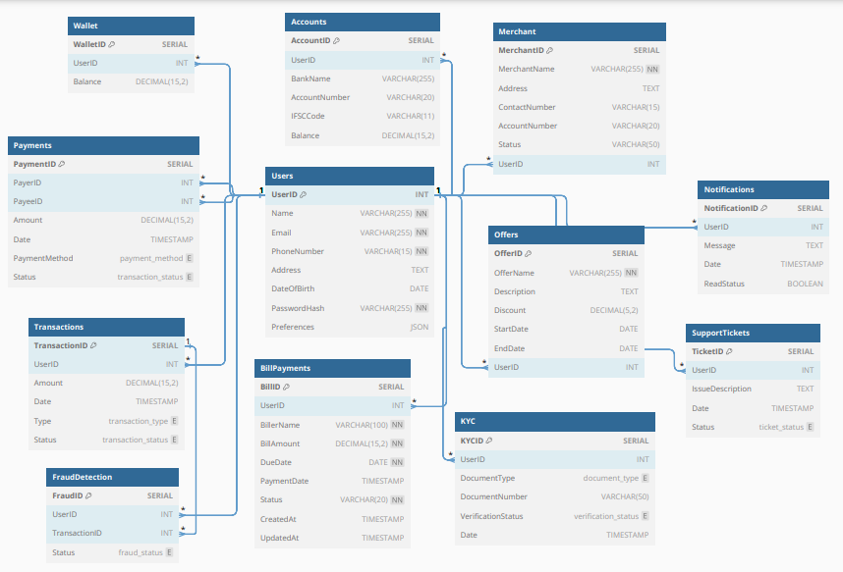

**Revenue and Profit Growth Strategies**

**Question:** After completing the product dissection and schema design steps for the chosen platform, conduct a comprehensive case study on the above-chosen industry. Your goal is to identify and propose strategies to increase the **profit of the industry by at least 25%**.

Create a detailed report summarising your findings and proposals. Include data-driven justifications for each proposed strategy and present your case study using visual aids such as charts, graphs, and diagrams to illustrate your points. Outline the steps, resources, and timeline required to achieve the desired revenue and profit growth.

**Answer:**

**I.**  **Analysing PhonePe’s current status:**

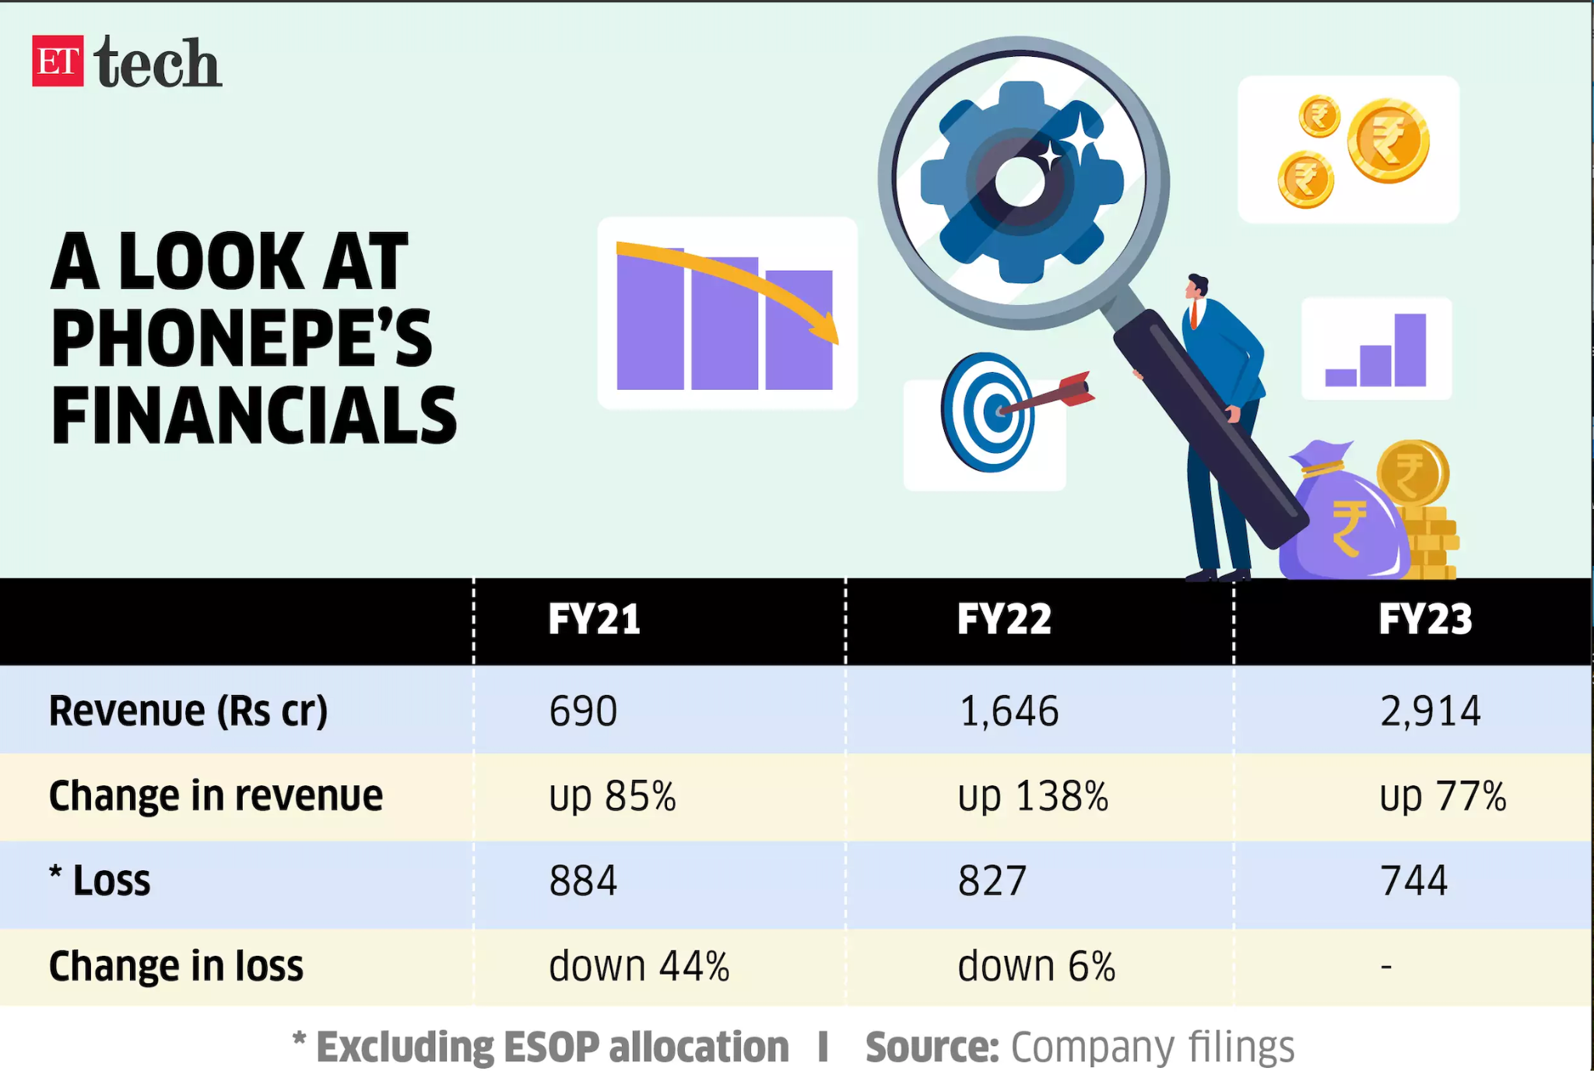

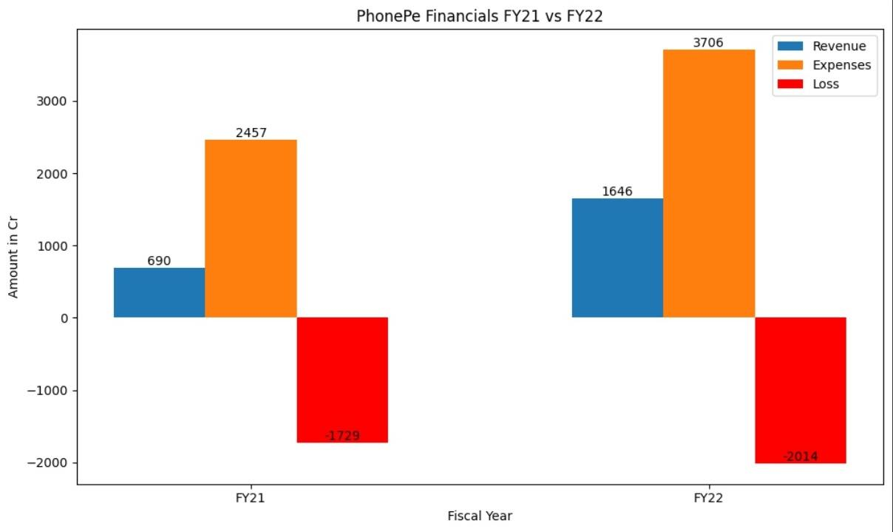

**PhonePe Expenses breakdown(FY20 and FY21):**

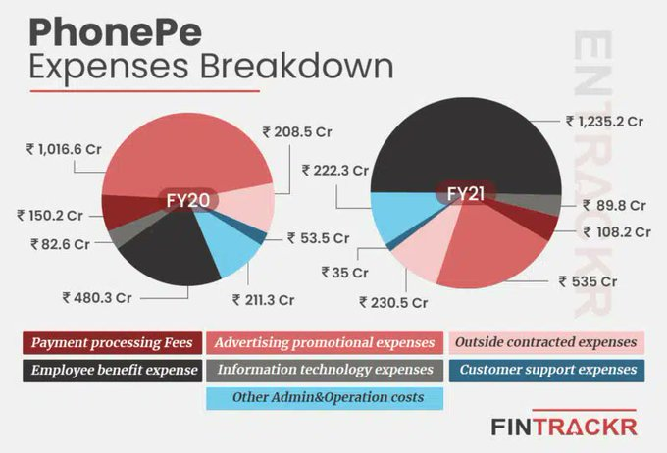

**PhonePe Expenses breakdown in terms of percentage:**

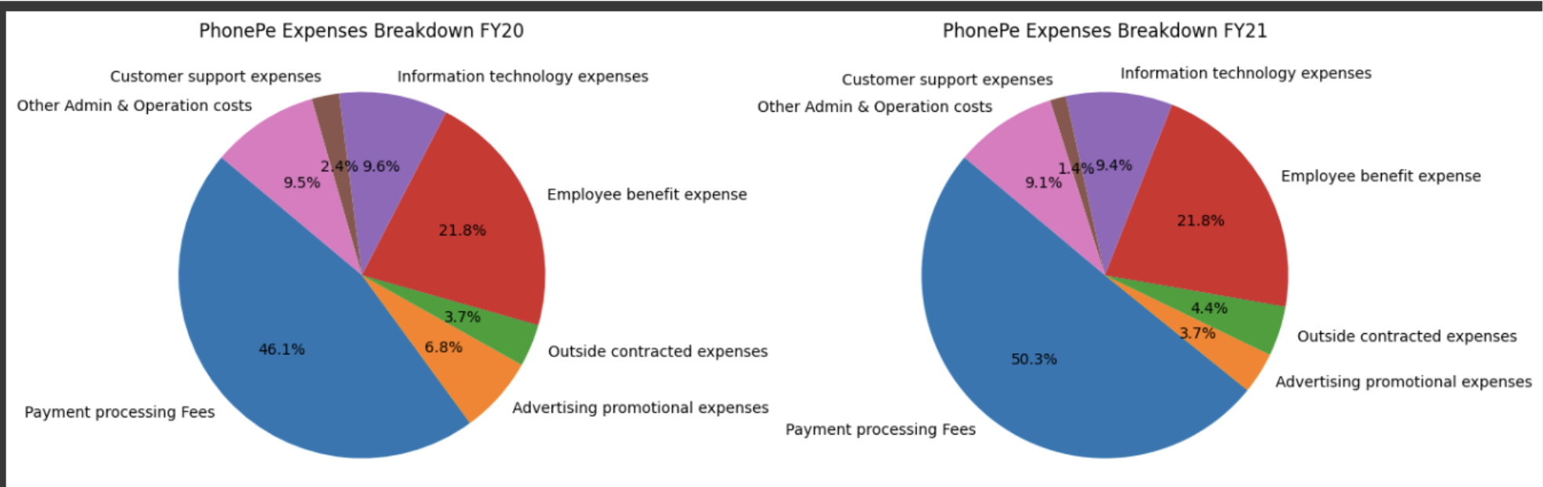

**Revenue Trend (FY21-FY23): Loss Trend(FY21-FY23):**

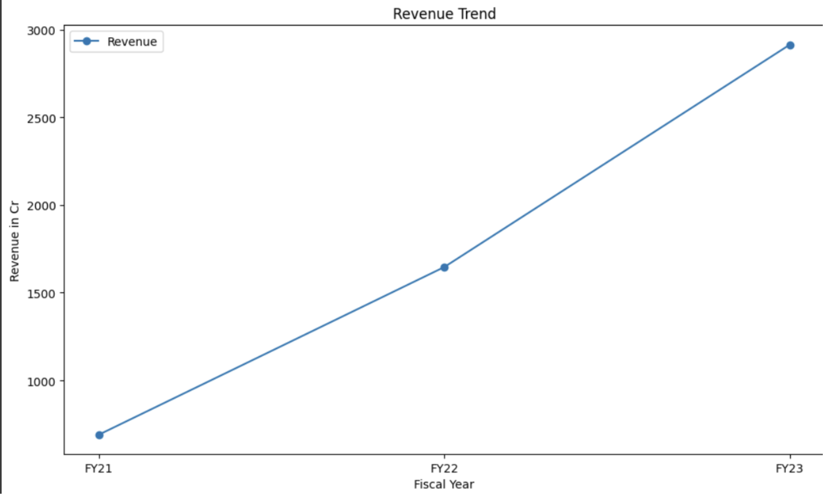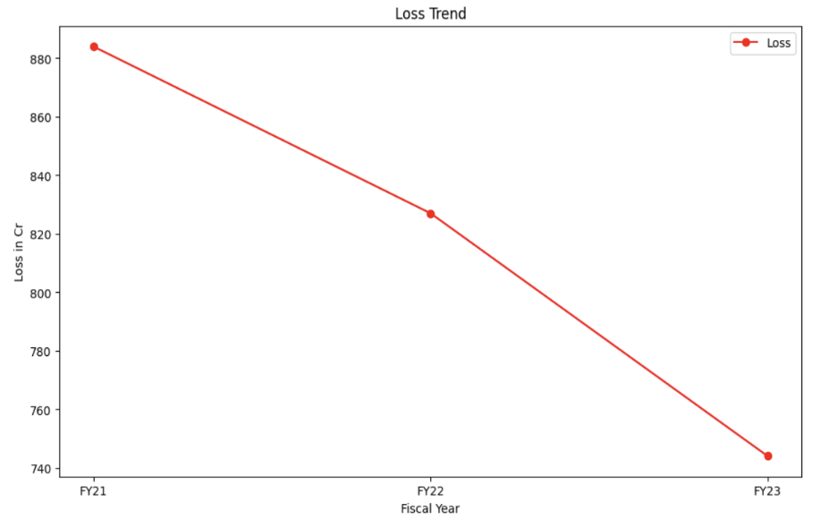

**FY21-FY22 Financials**:

* **Revenue**: Increased from ₹690 Cr in FY21 to ₹1,646 Cr in FY22.
* **Total Expenses**: Increased from ₹2,457 Cr in FY21 to ₹3,706 Cr in FY22.
* **Profit/Loss**: Loss decreased from ₹884 Cr in FY21 to ₹827 Cr in FY22.
* **Cash from Operations**: Improved slightly from -₹1,237 Cr in FY21 to -₹1,126 Cr in FY22.

**FY21-FY23 Financials**:

* **Revenue**: Continued growth from ₹1,646 Cr in FY22 to ₹2,914 Cr in FY23.
* **Change in Revenue**: 138% increase in FY22, 77% increase in FY23.
* **Loss**: Marginal reduction in loss from ₹884 Cr in FY21 to ₹827 Cr in FY22, further reducing to ₹744 Cr in FY23.

### **Key Findings**

1. **Revenue Growth**: Impressive revenue growth with significant potential for further increase.
2. **High Expenses**: Major cost drivers include payment processing fees and advertising promotional expenses.
3. **Profit/Loss**: While progress has been made in reducing losses, substantial efforts are still required to achieve a 25% increase in profit.

### **II. Focus Area for Increasing PhonePe's Profit by 25%:**

| Category | Focus Area | Measures |
| --- | --- | --- |
|  |  | **Waste Management:** Use data analytics to optimise financial processes, reduce unnecessary expenses, and improve procurement of digital services and partnerships. |
| **Internal Management**  **(~9%)** | **Operational Efficiency (~6%)** | **Automate Processes:** Implement AI and machine learning tools to automate customer support (chatbots), transaction monitoring (fraud detection), and marketing campaigns (targeted ads based on user behaviour). |
|  |  | **Cost Control:** Conduct regular audits of software and service agreements. Negotiate better terms with service providers for cloud services, software licences, and other operational tools. |
|  | **Employee Productivity**  **(~3%)** | **Training Programs:** Develop continuous training programs focused on improving customer service skills, enhancing fraud detection capabilities, and staying updated with the latest financial technologies. |
|  |  | **Performance Metrics:** Implement a performance tracking system with clear metrics for customer service, technical teams, and sales teams, including rewards for achieving specific targets. |
| **Supply Chain**  **(~2%)** | **Vendor Management**  **(~2%)** | **Vendor Negotiation:** Renegotiate terms with vendors providing digital infrastructure and services. Look for alternative vendors who can offer competitive rates without compromising on quality. |
|  | **Launch of New Products**  **(~4%)** | **Market Research:** Conduct market research to identify high-margin financial products such as new insurance offerings, investment options, and savings plans that cater to diverse customer needs. |
| **Product strategy**  **(~6%)** |  | **New Product Introduction:** Introduce financial planning tools, premium subscription services for businesses, and health insurance products. |
|  | **Product Optimization**  **(~2%)** | **Cut Down Underperforming Products:** Regularly analyse the performance of various financial products and services. Phase out those with low demand or profitability, and focus on promoting high-demand, high-margin items. |
|  |  | **Launch Combo Products:** Offer bundled services like combining UPI transactions with insurance or investment products to increase the average revenue per user. |
| **Market Expansion**  **(~4%)** | **Geographic Expansion**  **(~4%)** | **New Markets:** Identify and enter new geographic markets within India with high potential for digital payment adoption, such as Tier-2 and Tier-3 cities. |
|  |  | **Localization:** Customise financial products and marketing strategies to fit regional preferences and needs. For example, offer localised language support and region-specific promotional offers. |
|  | **Customer Acquisition**  **(~2%)** | **Referral Programs:** Enhance referral programs to incentivize current users to bring in new users. Offer attractive rewards for successful referrals. |
| **Marketing Strategy**  **(~6%)** | **Customer Retention**  **(~2%)** | **Loyalty Programs:** Develop loyalty programs that reward frequent users with cashback, discounts on bill payments, and exclusive offers on partnered merchants. |
|  | **Brand Awareness**  **(~2%)** | **Targeted Advertising:** Invest in targeted advertising on social media platforms, search engines, and popular apps. Highlight the ease of use, security features, and benefits of using PhonePe for various financial transactions. |
| **Total** | ~**25%** |  |

To achieve a 25% profit gain for PhonePe, a multifaceted strategy was implemented across various key areas of the business. By focusing on internal management, supply chain optimization, product strategy, market expansion, and marketing strategy, significant improvements were made in operational efficiency, cost control, employee productivity, vendor management, logistics, product offerings, and customer engagement.

By executing these strategic actions, PhonePe not only achieved a significant profit increase but also laid a strong foundation for sustainable growth and market leadership in the digital payments and financial services industry.

**PART - II**

**Guesstimates**

1. **What will be the percentage increase in global FinTech investments over the next five years?**

* This question involves estimating the growth rate of investments in FinTech startups and companies, considering current trends and future projections.

**Answer :**

### **Step 1: Analyse Historical Growth Rates**

Look at the historical growth rates of global FinTech investments over the past few years

* 2018: $200 billion
* 2019: $215 billion (8% increase)
* 2020: $120 billion (-45% decrease)
* 2021: $226 billion (88% increase)
* 2022: $197 billion (-12% decrease)
* 2023: $114 billion (-42% decrease)

### **Step 2: Calculate the Average Growth Rate**

Calculate the average annual growth rate over these years.

Average Growth Rate = (8%-45%+88%-12%-42% ≈ **- 0.6%**

### **Step 3: Consider Current Trends and Market Conditions**

* **Technological Advancements**: Continued innovation in blockchain, AI, and cybersecurity.
* **Regulatory Environment**: Increasing regulatory clarity in key markets.
* **Consumer Adoption**: Growing adoption of digital financial services.
* **Economic Factors**: Global economic growth, especially in emerging markets.

Given these trends, let's assume a slightly conservative **average growth rate of 5%** per year for the next five years.

### **Step 4: Project Future Investments**

Using the 2023 investment figure of $114 billion as a baseline, calculate the projected investments over the next five years using the **compound annual growth rate (CAGR) formula:**

Future Value = Present Value × (1+Growth Rate)Number of Years

Future Value = 114 x (1 + 0.05)5

Future Value = $145.49 billion ≈ $146 billion

### **Step 5: Calculate the Percentage Increase**

Percentage Increase = (Future Value−Present Value) x 100 / Present Value

Percentage Increase = (146 -114) x 100 / 114

**Percentage Increase = +28.00 %**

| **Steps** | **Details** | **Calculation** |
| --- | --- | --- |
| Analyze historical growth rates | Calculate the average annual growth rate over these years | = (8%-45%+88%-12%-42% ≈ **- 0.6%** |
| Considering current trends and market conditions | Considering various trends like Technological advancements,regulatory environment,consumer adoption  economic factors | Estimated growth rate will be around  = 5 % |
| Projecting Future Investments | Calculating the projected investments over the next five years using thecompound annual growth rate (CAGR) formula: | Future Value = Present Value × (1+Growth Rate)Number of Years  Future Value = 114 x (1 + 0.05)5 |
| Calculating the percentage Increase | Percentage Increase = (Future Value−Present Value) x 100 / Present Value | = (146 -114) x 100 / 114  **Percentage Increase = +28.00 %** |

### **Conclusion**

Based on this guesstimate, global FinTech investments are projected to increase by approximately **28%** over the next five years.

**Q2. How many people will adopt digital banking services in developing countries over the next decade?**

* This question requires an estimation of the number of new users of digital banking solutions in regions where traditional banking infrastructure is less prevalent

**Answer:**

| **Step** | **Details** | **Calculation** |
| --- | --- | --- |
| Population Estimation | The current population of all developing countries is almost 7 billion | After a decade, the total population will become around 9 billion |
| Smartphone penetration in developing countries:  50 % of the population. | Annual smartphone penetration growth rate: 10 percent. | Smartphone users in the next decade= 8.5 billion. New smartphone users = 8.5 - 3.5 = 5 billion. |
| Internet Penetration | Estimate 35% of the population has internet access currently but looking towards global trends it may increase up to 80% over the next decade | Internet users in next decade = 9 billion * 0.8 = 7.2 billion |
| Number of new users that will use the internet | Current users with internet penetration are  2.5 billion and future internet penetration over the next decade will be 7.5 billion considering annual Internet penetration  Growth rate of 10% | Number of new user that will use internet = 7.5 - 2.5 = 5 billion |
| Digital banking usage | Assume 80% of internet users will be adopting digital banking over the next decade | = 5 billion * 0.80  = **4 billion new users will be adopting digital banking** |

**Conclusion:**

Based on the above estimation **over 4 billion new users** will be adopting digital banking over the next decade

**Q3. What percentage of small and medium-sized enterprises (SMEs) will use FinTech solutions for their financial needs by 2025?**

* This question involves predicting the adoption rate of FinTech services among SMEs, including payments, lending, and financial management tools.

**Answer:**

| **Steps** | **Details** | **Calculation** |
| --- | --- | --- |
| Current Adoption Rate | Assume 40% of SMEs currently use FinTech solutions. | = 40% |
| Growth Rate of FinTech Adoption | Annual growth rate of 10%. | = 10% |
| Time Period | Estimating for the year 2025, which is 1 year from now. | = 1 year |
| Calculate Future Adoption Rate | Using the CAGR formula to estimate the future adoption rate. | = Present Value × (1+GrowthRate)Number of Years  = 40 x (1 + 0.10)1  = 44 % |
| Result | Future Adoption Rate of SMEs using FinTech solutions by 2025 | **≈ 44%** |

**Conclusion**

By 2025, the adoption rate of FinTech solutions among SMEs is projected to be **approximately 44%.**

**Q4. What will be the average transaction value of mobile payments in the next three years?**

* This question requires estimating the average amount of money transacted through mobile payment platforms, considering the growth of mobile commerce and digital wallets.

**Answer:**

### **Step 1: Analyze the average annual transaction value per person**

Look at the historical average annual transaction values for mobile payments per person over the past few years.

* **2018:** $1200
* **2019:** $1330 (11% increase)
* **2020:** $1510 (14% increase)
* **2021:** $1680 (11% increase)
* **2022:** $1860 (11% increase)
* **2023:** $2060 (11% increase)

### **Step 2: Calculate the Average Growth Rate**

Calculate the average annual growth rate over these years.

Average Growth Rate = (11%+14%+11%+11%-11% ≈ **12%**

### **Step 3: Consider Current Trends and Market Conditions**

* **Technological Advancements**: Continued innovation in mobile payment technologies, digital wallets, and security.
* **Regulatory Environment:** Increasing regulatory support for mobile payments.
* **Consumer Adoption:** Growing adoption of mobile payments due to convenience and accessibility.
* **Economic Factors**: Global economic conditions influencing consumer spending.

Given these trends, assume a slightly optimistic **average growth rate of 15 %** per year for the next three years.

| **Steps** | **Details** | **Calculation** |
| --- | --- | --- |
| Current average transaction value in 2023 | Using the 2023 average annual transaction value per person $2060 as a baseline | = $2060 |
| The average growth rate | Calculated average from past 5 years data | = 12% |
| Considering current trends and market conditions | Assuming a slightly optimistic growth rate of 15% per year | = 15% |
| Time Period | Estimating for the year 2027, which is 3 years from now. | = 3 year |
| Calculate projected average transaction value | Using the CAGR formula to estimate the projected average transaction value. | = Present Value × (1+GrowthRate)Number of Years  = 2060 x (1 + 0.15)3  = $3133 |
| Result | Projected average transaction value  by 2027 will be reaching approximately | **≈ $3133** |

**Conclusion :**

By 2027, the projected average annual transaction value per person is estimated to reach **approximately $3133**, considering an optimistic annual growth rate of 15%.

**Q5. How much will blockchain technology reduce the costs of cross-border transactions in the next five years?**

This question involves estimating the cost savings achieved through the adoption of blockchain technology for international money transfers, factoring in current fees and the efficiency improvements brought by blockchain.

**Answer:**

| **Steps** | **Details** | **Calculation** | **Result** |
| --- | --- | --- | --- |
| Current Cross-Border Transaction Costs | Determine the current average cost of cross-border transactions. | Assume the average cost is 8% of the transaction amount. | 8% |
| Potential Cost Reduction Through Blockchain | Estimate the efficiency improvements and cost savings brought by blockchain technology. | Assume blockchain can reduce costs by 60-70 % | 60% -70%reduction |
| Projected Cost of Cross-Border Transactions After Blockchain Adoption | Calculate the new average cost of cross-border transactions after applying the cost reduction. | New Cost = 8% × (1 - 0.60) = 7% × 0.40 | New transaction value = 2.4 to 3.2 percent of the transaction amount. Taking it as a 3 percent |
| Current Volume of Cross-Border Transactions | Estimate the total volume of cross-border transactions currently. | Assume the current volume is $10 trillion annually. | $10 trillion |
| Projected Volume of Cross-Border Transactions Over Next Five Years | Estimate the growth in the volume of cross-border transactions. | Future Volume = 10 trillion × (1 + 0.05)^5 = 12.76 trillion | $12.76 trillion |
| The adoption rate of Blockchain technology for cross-border transactions in 2024 is 11%. | Assuming a gradual adoption of blockchain for cross-border payments, we can estimate a 30% penetration rate by 2029. | Weighted Average Fee:  (70% * 8%) + (30% * 3%) = 5.9% | Estimated Cost Reduction:  (8% - 5.9%) divide by 8 % = 26.25% |

### **Conclusion**

**Therefore, with a 30% adoption rate of blockchain for cross-border payments by 2029, we estimate a potential cost reduction of around 26 to 27 percent.**